Name: _______________________________ Period: _____ Date: ________________________

Heat Transfer Internet Scavenger Hunt
Directions: Go through the websites below and answer the questions. You may have to scroll down or click on links on the webpage to find the answers.
- http://coolcosmos.ipac.caltech.edu/cosmic_classroom/light_lessons/thermal/index.html
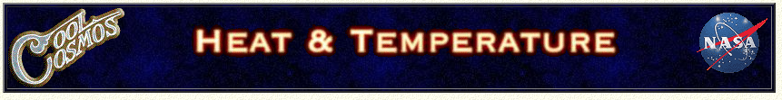
- Click on the first link from this homepage. Then use the links at the bottom. Each line below separates one page from the next.
1. Where does thermal energy come from (what causes it)?

2. Thermal energy can come from other forms of energy. Give several examples how.

3. What does the speed of molecules have to do with thermal energy?

4. What is temperature a measure of?

5. Does temperature depend on the amount of substance present? Explain.

6. Heat is different from temperature. What three things does heat depend on?

7. Give an example of how things can have the same temperature, but different
heats.

8. Heat will always transfer from ________________________ to ________________________
temperatures.

There are three methods of heat transfer. Define each (what causes it) and describe
how they happen. This link does a really nice job of illustrating all 3 of these a little differently:
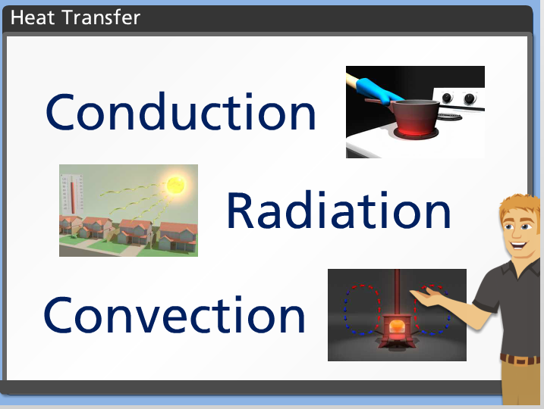
- http://www.wisc-online.com/Objects/ViewObject.aspx?ID=sce304

9. – 10. Conduction
Is caused by:

Describe how:

11. – 12. Convection
Is caused by:

Describe how:

13. – 14. Radiation
Is caused by:

Describe how:

15. Temperature is measured with a thermometer. How is heat measured and in
what units?

Name the temperature at which water freezes and boils in…
16. Fahrenheit

17. Celsius

18. Kelvin

19. What is Absolute Zero (what happens and what temp.?)

