CONDUCTION, CONVECTION, & RADIATION
Go to duckyssite.weebly.com and click on “biology’ under the “virtual lab” tab. Scroll down until you see the icon below. Click on the icon to open to correct web page and complete the questions below.

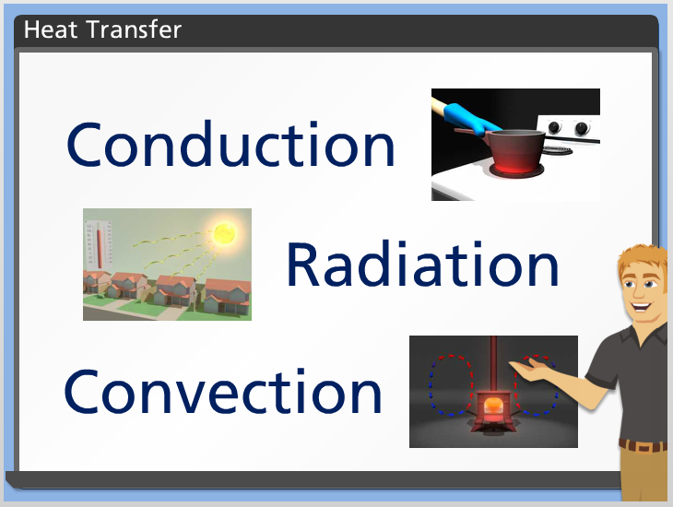

- Describe how heat is transferred through conduction

- List 4 good conductors and 4 poor conductors

  - Good Conductors
    - –
    - –
    - –
    - –

  - Poor Conductors
    - –
    - –
    - –
    - –

- Where does radiation come from?

- What happens when electromagnetic waves come in contact with an object?

- List three other examples of radiation
  - Radiation
    - –
    - –
    - –

- Convection requires a _____________________ or _______________________ medium.

- Describe or illustrate how convection currents are created

- List 4 other examples of Convection.
  - Convection
    - –
    - –
    - –
    - -

