Follow the link to complete the questions below…. http://www.gcse.com/fm/dtg.htm

- Draw a basic time graph without data from the main page.
- Click next at the bottom right screen.
- Illustrate a vehicle that is not moving on the graph below.
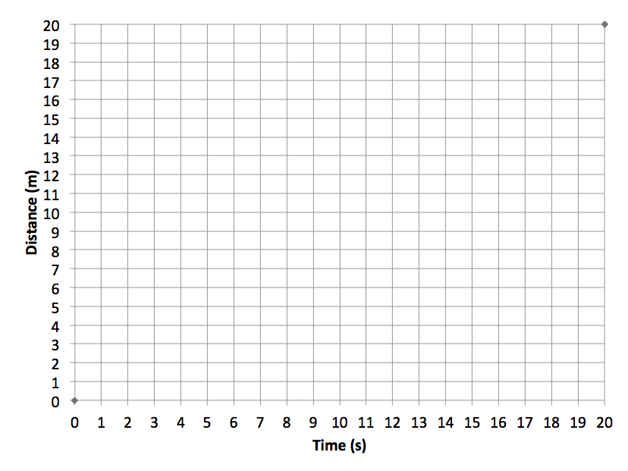
- Click next
- Illustrate a vehicle that is moving at a steady pace on the graph below.
- Click next
- How would you be able to determine if a car is moving faster than another car?
- Click next
- Illustrate a vehicle who has increased its speed on graph below.
- Click next
- Click next again
- How would you determine the speed of the yellow car using the graph on the screen? Show you work.
- Which is going faster, yellow or blue?
- Wait for Mrs. Ducky before you go any further.
- Use the graph below to determine the speed of all three cars and list the cars in order by their speeds beginning from slowest to the fastest.
