[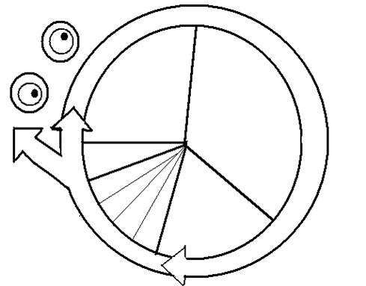](http://www.google.com/url?sa=i&source=images&cd=&cad=rja&docid=wYMTtxEt7LguoM&tbnid=7B9oXl0uiA9QYM:&ved=0CAgQjRwwAA&url=http://vanessa.jeffreyjason.com/wp-content/uploads/2011/06/Cell-Cycle-Notes-student.html&ei=thKJUZK5Boe-9QTwsYCwBg&psig=AFQjCNFe6A8O7H8rv_cNJDeOzprXos2jGw&ust=1368024118172193)

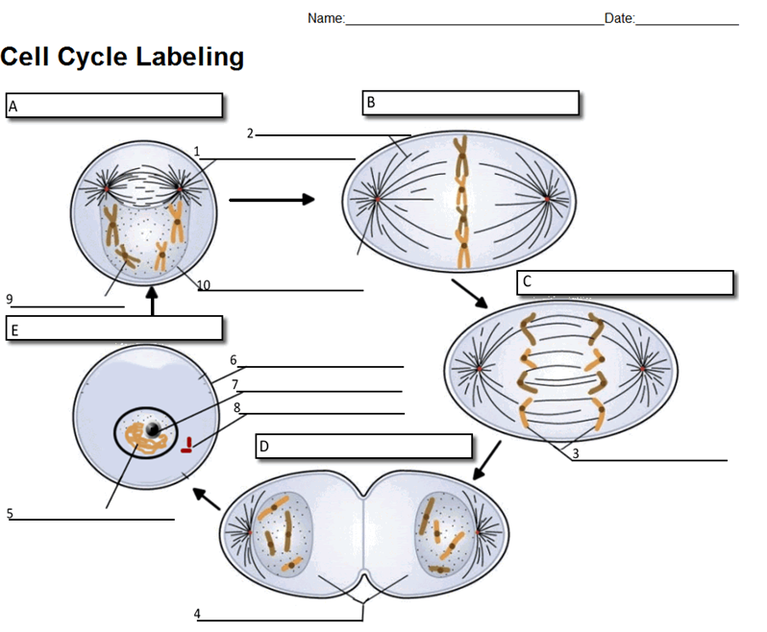

**Mitosis**